Name: Filip Kin
Date: 2020-04-22
15.07 Picture Lab Worksheet
Directions: Make note of your responses to the following questions as you work through the activities and exercise in the lesson.
Activity 5 Questions
Question | Yes | No
- Is the method getPixels2D in the Picture.java class? |  | X
- Is the method getPixels2D in the SimplePicture.java class? | X
- Will the following code compile?  DigitalPicture p = new DigitalPicture(); |  | X
- Assuming a no-argument constructor exists for SimplePicture, will the following code compile?  DigitalPicture p = new SimplePicture(); | X
- Assuming a no-argument constructor exists for Picture, will the following code compile?  DigitalPicture p = new Picture(); | X
- Assuming a no-argument constructor exists for Picture, will the following code compile?  SimplePicture p = new Picture(); | X
- Assuming a no-argument constructor exists for SimplePicture, will the following code compile?  Picture p = new SimplePicture(); |  | X

Activity 5 Exercise Results

- Describe your method for keepOnly red, blue, or green.
public void keepOnlyRed(){
Pixel[][] pixels = this.getPixels2D();
for(Pixel[] rowArray : pixels){
for(Pixel pixelObj : rowArray){
pixelObj.setGreen(0);
pixelObj.setBlue(0);
}
}
}
- For the negate method, paste your code related to calculating and setting the values for red, blue, and green.
public void negate(){
Pixel[][] pixels = this.getPixels2D();
for(Pixel[] rowArray : pixels){
for(Pixel pixelObj : rowArray){
pixelObj.setRed(255-pixelObj.getRed());
pixelObj.setGreen(255-pixelObj.getGreen());
pixelObj.setBlue(255-pixelObj.getBlue());
}
}
}
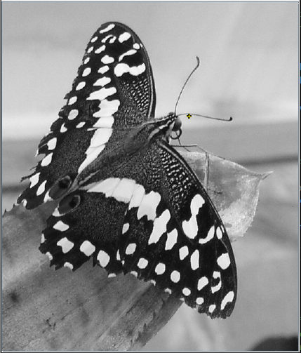
- Paste a copy of the image that is the result of calling the grayscale.
- For the method fixUnderwater, describe the algorithm you'd propose to accomplish the task.
I would set the blue value to 50% of the current value to make the fishes more visible
Activity 6 Exercise Results
- Paste the image that is the result of calling the method mirrorVerticalRightToLeft.
public void mirrorVerticalRightToLeft() {
Pixel[][] pixels = this.getPixels2D();
Pixel leftPixel = null;
Pixel rightPixel = null;
int width = pixels[0].length;
for (int row = 0; row < pixels.length; row++) {
for (int col = 0; col < width / 2; col++) {
leftPixel = pixels[row][col];
rightPixel = pixels[row][width - 1 - col];
leftPixel.setColor(rightPixel.getColor());
}
}
}
- Describe the algorithm for the method mirrorHorizontal works.
public void mirrorHorizontal() {
Pixel[][] pixels = this.getPixels2D();
Pixel topPixel = null;
Pixel bottomPixel = null;
int width = pixels[0].length;
int height = pixels.length;
for (int row = 0; row < height; row++) {
for (int col = 0; col < width; col++) {
topPixel = pixels[row][col];
bottomPixel = pixels[height - 1 - row][col];
bottomPixel.setColor(topPixel.getColor());
}
}
}

- Paste the image that is the result of calling the method mirrorHorizontalBotToTop.
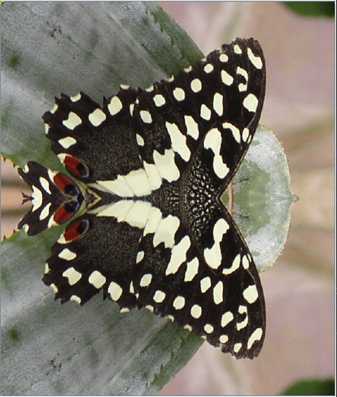
Activity 7 Questions
  - How many times would the body of this nested for loop execute? 90 Times
for(int row = 7; row < 17; row++)
for(int col = 6; col < 15; col++)
  - How many times would the body of this nested for loop execute? 90 Times
for(int row = 5; row <= 11; row++)
for(int col = 3; col <= 18; col++)

Activity 7 Exercise Results

- What value is displayed for count after the nested loop ends in the mirrorTemple method? 18410
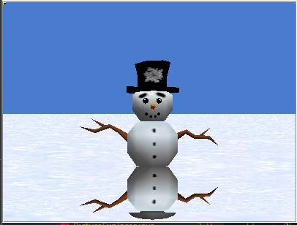
- Paste the image that is the result of calling the method mirrorArms
- .
Paste the image that is the result of calling the method mirrorGull.
